Activity 1
Aim: Create CSS document by using ID selector
Learning outcome: Able to create Styles of web pages using CSS.
Duration: 1 hour
List of Hardware/Software requirements:
- Laptop/Computer with Linux OS - Ubuntu 18.04 LTS
- Editor (Default GEDIT) and a Browser
Program:
<!DOCTYPE html>
<html>
<head> <!-- Document Head Starts -->
<title> ID Selector </title>
<style>
/* Style the element with the id "myHeader” */
#myHeader {
background-color: lightblue;
color: black;
padding: 40px;
text-align: center; }
</style>
</head> <!-- Document Head Ends -->
<body> <!-- Document Body Starts -->
<!--This is Heading Tag with id myHeader-->
<h1 id="myHeader">My Header</h1>
</body> <! -- Document Body Ends -->
</html>

Output/Results snippet:
A simple HTML webpage with the body CSS id Selector.
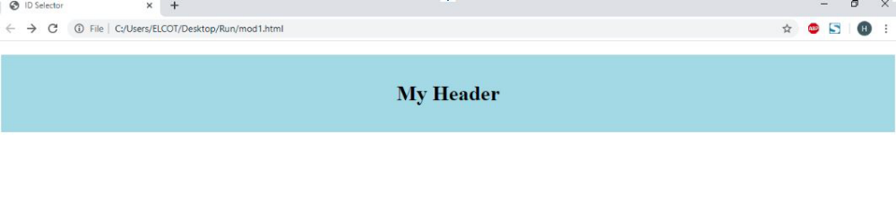

References:
- HTML Introduction - https://www.w3schools.com/html/html_intro.asp

Activity 2
Aim: Create CSS document by using Class selector, Universal selector Grouping selector
Learning outcome: Able to create Styles of web pages using CSS.
Duration: 1 hour
List of Hardware/Software requirements:
- Laptop/Computer with Linux OS - Ubuntu 18.04 LTS
- Editor (Default GEDIT) and a Browser
Program:
<!DOCTYPE html>
<html>
<head> <!-- Document Head Starts -->
<title> Selectors </title>
<style>
/* Style the element with the id "myHeader” */
#myHeader {
background-color: lightblue;
color: black;
padding: 40px;
text-align: center;
}
/* Style all elements with the class name "city" */
.city {
background-color: tomato;
color: white;
padding: 10px;
}
/* Style all elements with the Group name "h5,h6" */

h5,h6{
margin-left: 500px;
color: red;
background-color: yellow;
width: 35%;
height: 50px;
text-align: center;
}
</style>
</head> <!-- Document Head Ends -->
<body> <!-- Document Body Starts -->
<!-- A unique element -->
<h1 id="myHeader">My Cities</h1>
<!-- Multiple similar elements -->
<h2 class="city">London</h2>
<p>London is the capital of England.</p>
<h2 class="city">Paris</h2>
<p>Paris is the capital of France.</p>
<h2 class="city">Tokyo</h2>
<p>Tokyo is the capital of Japan.</p>
<h5>Welcome to Grouping</h5>
<h6>Good Bye</h6>
</body> <! -- Document Body Ends -->
</html>

Output/Results snippet:
A simple HTML webpage with the body CSS Selectors.
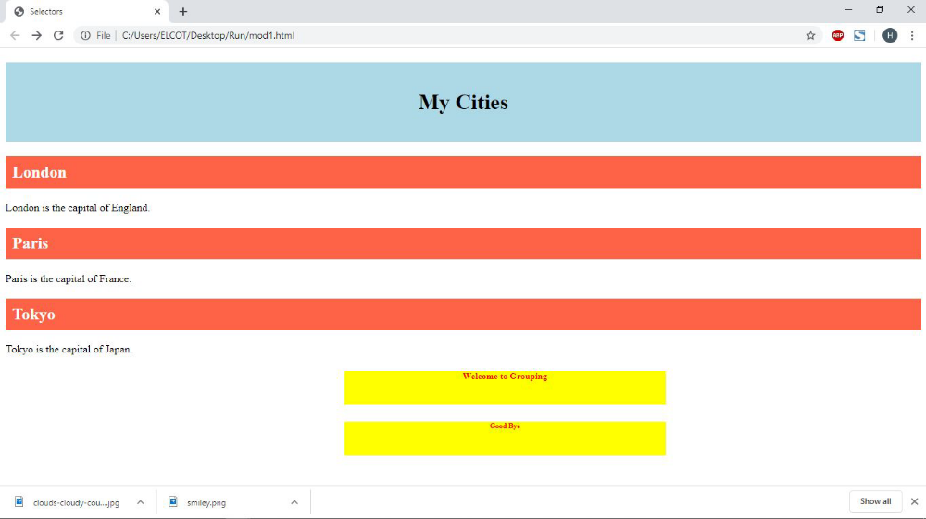

References:
- HTML Introduction - https://www.w3schools.com/html/html_intro.asp

Activity 3
Aim: Create CSS document with fonts: Bold, Italics, oblique
Learning outcome: Able to create Styles of web pages using CSS.
Duration: 1 hour
List of Hardware/Software requirements:
- Laptop/Computer with Linux OS - Ubuntu 18.04 LTS
- Editor (Default GEDIT) and a Browser
Program:
<!DOCTYPE html>
<html>
<head> <!-- Document Head Starts -->
<title> Fonts</title>
<style>
/* Style all elements with the paragraph class name "p.a,p.b,p.c" */
p.a { font-style: bolder;}
p.b {font-style: italic;}
p.c {font-style: oblique;}
</style>
</head> <!-- Document Head Ends -->
<body> <!-- Document Body Starts -->
<h2>The font-style Property</h2> <!--This is Heading-->
<p class="a">This is a paragraph, bolder.</p> <!--Paragraph Element with bolder-->
<p class="b">This is a paragraph, italic.</p> <!--Paragraph Element with Italic-->
<p class="c">This is a paragraph, oblique.</p> <!--Paragraph Element with oblique -->
</body> <! -- Document Body Ends -->
</html>

Output/Results snippet:
A simple HTML webpage with the body CSS Fonts.
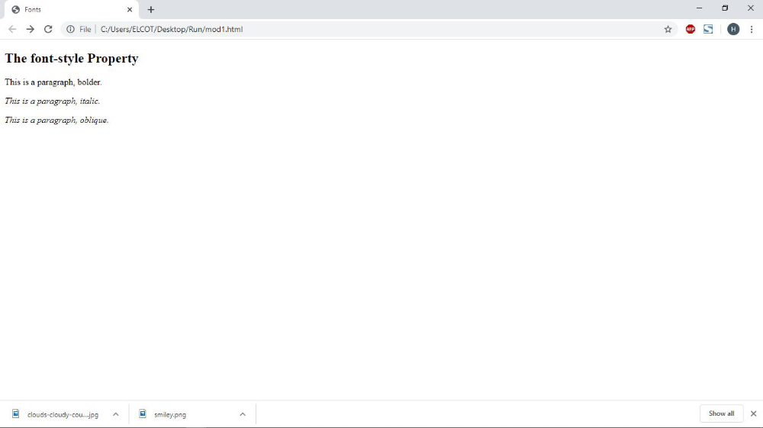

References:
- HTML Introduction - https://www.w3schools.com/html/html_intro.asp

Activity 4
Aim: Design Style sheet document with text transformation: Uppercase, Lowercase and capitalize
Learning outcome: Able to create style of web pages using CSS.
Duration: 1 hour
List of Hardware/Software requirements:
- Laptop/Computer with Linux OS - Ubuntu 18.04 LTS
- Editor (Default Gedit or any other) and a Browser
Program:
<!DOCTYPE html>
<html>
<head>
<style>
/* Style the element with the class "a" */
div.a {
text-transform: uppercase;
}
/* Style the element with the class "b" */
div.b {
text-transform: lowercase;
}
/* Style the element with the class "c" */
div.c {
text-transform: capitalize;
}
</style>
</head>
<body>
<h2>The text-transform Property</h2>
<h2>text-transform: uppercase:</h2>
<div class="a">Welcome to CSS</div>
<h2>text-transform: lowercase:</h2>
<div class="b">Welcome to CSS</div>
<h2>text-transform: capitalize:</h2>
<div class="c">Welcome to CSS</div>
</body>
</html>

Output/Results snippet:
A Page with all the div has applied CSS
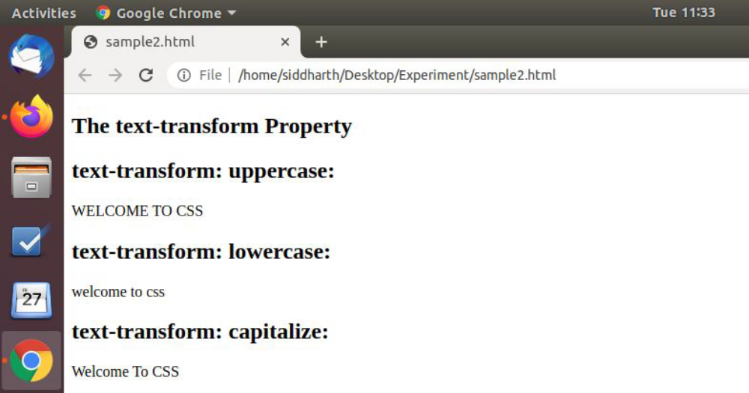

References:
- https://www.w3schools.com/html/html_intro.asp
- https://www.tutorialspoint.com/css/index.htm
- https://www.javatpoint.com/css-tutorial

Activity 5
Aim: Create CSS document with font size in different pixels
Learning outcome: Able to create style of web pages using CSS.
Duration: 1 hour
List of Hardware/Software requirements:
- Laptop/Computer with Linux OS - Ubuntu 18.04 LTS
- Editor (Default Gedit ) and a Browser
Program:
<!DOCTYPE html>
<html>
<head>
<style>
/*setting the font size of the heading tag h1*/
h1 {
font-size: 20px;
}
/*setting the font size of the heading tag h2*/
h2 {
font-size: 18px;
}
/*setting the font size of the paragraph*/
p {
font-size: 14px;
}
</style>
</head>
<body>
<h1>This is heading 1</h1>
<h2>This is heading 2</h2>
<p>This is a paragraph.</p>
<p>This is another paragraph.</p>
</body>
</html>

Output/Results snippet
Applied CSS on heading and paragraph.
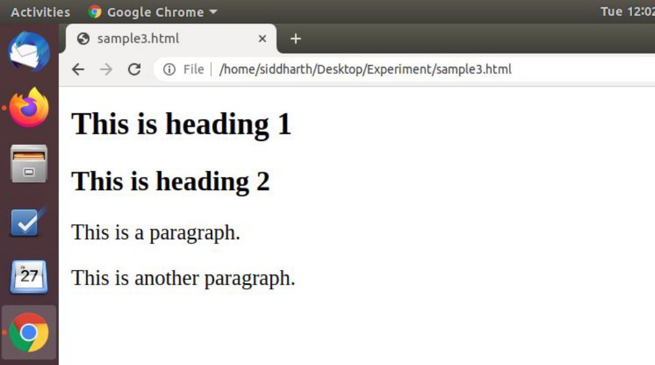

References:
- https://www.w3schools.com/html/html_intro.asp
- https://www.tutorialspoint.com/css/index.htm
- https://www.javatpoint.com/css-tutorial

Activity 6
Aim: Create CSS document with font weight thinner, thicker, bold
Learning outcome: Able to create style of web pages using CSS.
Duration: 1 hour
List of Hardware/Software requirements:
- Laptop/Computer with Linux OS - Ubuntu 18.04 LTS
- Editor (Default GEDIT) and a Browser
Program:
<!DOCTYPE html>
<html>
<head>
<style>
/*setting the font weight of the paragraph of class ".normal"*/
p.normal {
font-weight: normal;
}
/*setting the font weight of the paragraph of class ".light"*/
p.light {
font-weight: lighter; }
/*setting the font weight of the paragraph of class ".thick"*/
p.thick {
font-weight: bold; }
/*setting the font weight of the paragraph of class ".thicker"*/
p.thicker {
font-weight: 900; }
</style>
</head>
<body>
<h2>The font-weight Property</h2>
<p class="normal">This is a paragraph.</p>
<p class="light">This is a paragraph.</p>
<p class="thick">This is a paragraph.</p>
<p class="thicker">This is a paragraph.</p>
</body>
</html>

Output/Results snippet
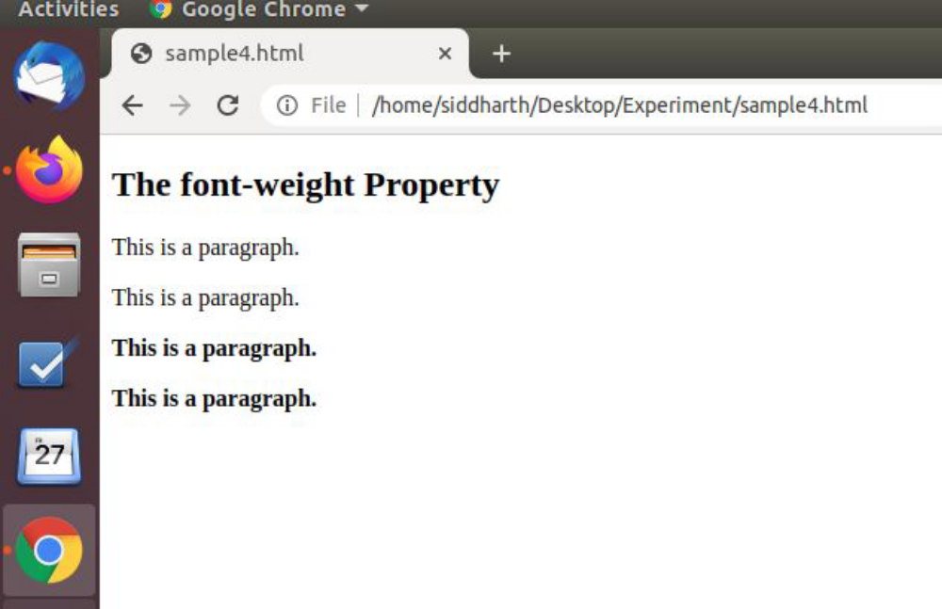

References:
- https://www.w3schools.com/html/html_intro.asp
- https://www.tutorialspoint.com/css/index.htm
- https://www.javatpoint.com/css-tutorial

Activity 7
Aim: Create CSS document with alignment center, right and left
Learning outcome: Able to create style of web pages using CSS.
Duration: 1 hour
List of Hardware/Software requirements:
- Laptop/Computer with Linux OS - Ubuntu 18.04 LTS
- Editor (default Gedit ) and a Browser
Program:
<!DOCTYPE html>
<html>
<head>
<style>
/*setting the alignment of the div of class ".a"*/
div.a {
text-align: center;
}
/*setting the alignment of the div of class ".b"*/
div.b {
text-align: left;
}
/*setting the alignment of the div of class ".c"*/
div.c {
text-align: right;
}
/*setting the alignment of the div of class ".d"*/
div.d {
text-align: justify;
}
</style>
</head>
<body>
<h2>The text-align Property</h2>
<div class="a">
<h2>text-align: center:</h2>
<p>Welcome to alignment Welcome to alignment Welcome to alignment Welcome to alignment</p>
</div>
<div class="b">
<h2>text-align: left:</h2>
<p>Welcome to alignment Welcome to alignment Welcome to alignment Welcome to alignment</p>
</div>
<div class="c">
<h2>text-align: right:</h2>
<p>Welcome to alignment Welcome to alignment Welcome to alignment Welcome to alignment</p>
</div>
<div class="d">
<h2>text-align: justify:</h2>
<p>Welcome to alignment Welcome to alignment Welcome to alignment Welcome to alignment</p>
</div>
</body>
</html>

Output/Results snippet
Alignment of the divisions with text-align property.
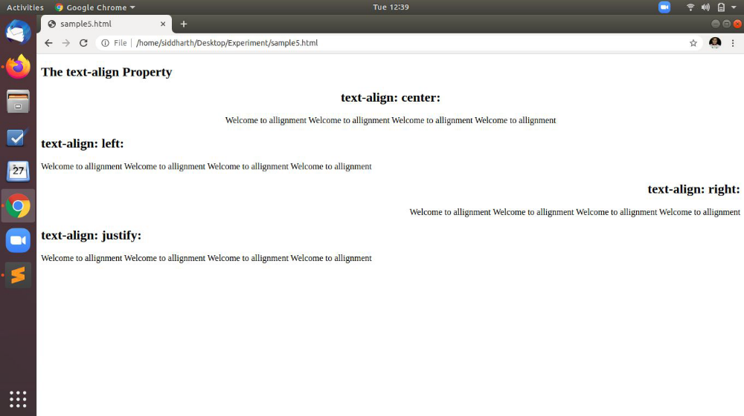

References:
- https://www.w3schools.com/html/html_intro.asp
- https://www.tutorialspoint.com/css/index.htm
- https://www.javatpoint.com/css-tutorial

Activity 8
Aim: Create CSS document with background colors and font colors
Learning outcome: Able to create style of web pages using CSS.
Duration: 1 hour
List of Hardware/Software requirements:
- Laptop/Computer with Linux OS - Ubuntu 18.04 LTS
- Editor (Default GEDIT) with a Browser
Program:
<!DOCTYPE html>
<html>
<head>
<style>
/*setting the background color of body */
body {
background-color: #fefbd8; }
/*setting the background color of heading and also change its color */
h1 {
background-color: #80ced6;
color: #006699; }
/*changing the background color of division with its color */
div {
background-color: #d5f4e6;
color: #4CAF50; }
/*setting the background color of span tag */
span {
background-color: #f18973; }
</style>
</head>
<body>
<h1>Background Color</h1>
<div>Set a background color for a div element.</div>
<p>Set a <span>background color</span> for only a part of a text.</p>
</body>
</html>

Output/Results snippet
Background color changes for heading, div and span.
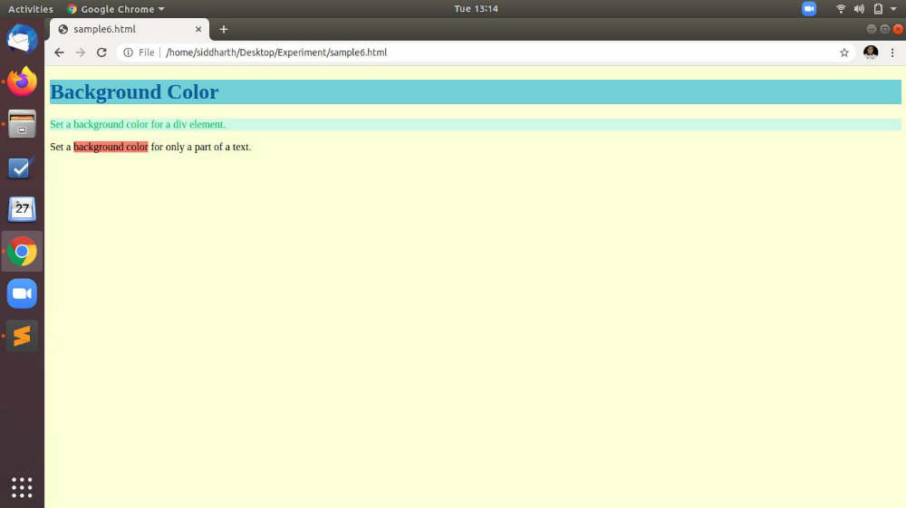

References:
- https://www.w3schools.com/html/html_intro.asp
- https://www.tutorialspoint.com/css/index.htm
- https://www.javatpoint.com/css-tutorial

Activity 9
Aim: Create CSS document with text hovering
Learning outcome: Able to create style of web pages using CSS.
Duration: 1 hour
List of Hardware/Software requirements:
- Laptop/Computer with Linux OS - Ubuntu 18.04 LTS
- Editor (Default GEDIT) with a Browser
Program:
<!DOCTYPE html>
<html>
<head>
<style>
/*setting the background color on hover of the mouse */
a:hover {
background-color: yellow; }
</style>
</head>
<body>
<a href=”https://www.google.com”>google.com</a>
<a href=”https://www.wikipedia.org”>22ikipedia.org</a>
<p><b>Note:</b> The :hover selector style links on mouse-over.</p>
</body>
</html>

Output/Results snippet
A mouse occurs when a mouse pointer is above link.
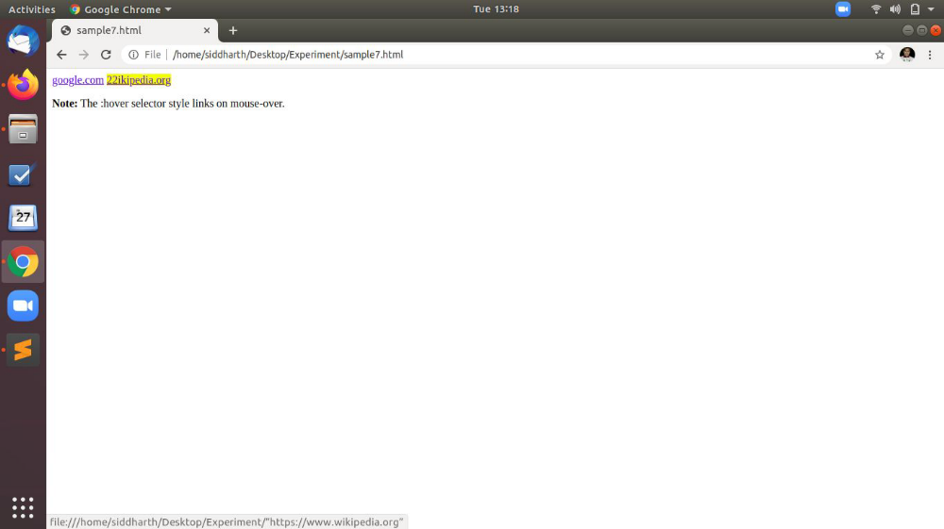

References:
- https://www.w3schools.com/html/html_intro.asp
- https://www.tutorialspoint.com/css/index.htm
- https://www.javatpoint.com/css-tutorial

Activity 10
Aim: Create CSS document with text decoration
Learning outcome: Able to create style of web pages using CSS.
Duration: 1 hour
List of Hardware/Software requirements:
- Laptop/Computer with Linux OS - Ubuntu 18.04 LTS
- Editor (default gedit) with Browser
Program:
<!DOCTYPE html>
<html>
<head>
<style>
/*setting the text decoration with overline property on h1 tag */
h1 {
text-decoration: overline; }
/*setting the text decoration with line-through property on h2 tag */
h2 {
text-decoration: line-through; }
/*setting the text decoration with underline property on h3 tag */
h3 {
text-decoration: underline; }
/*setting the text decoration with overline & underline property on h4 tag */
h4 {
text-decoration: underline overline; }
</style>
</head>
<body>
<h4>This is heading 1</h4>
<h3>This is heading 2</h3>
<h2>This is heading 3</h2>
<h1>This is heading 4</h1>
</body>
</html>

Output/Results snippet
Decorate heading with line-through property.
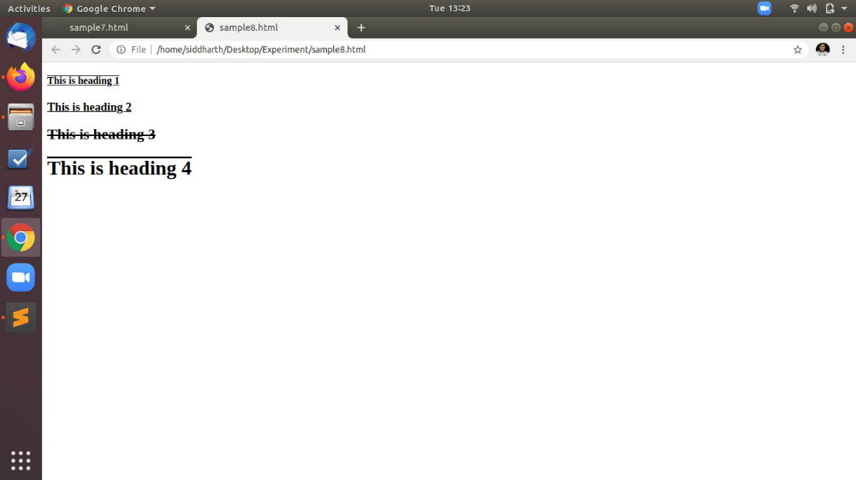

References:
- https://www.w3schools.com/html/html_intro.asp
- https://www.tutorialspoint.com/css/index.htm
- https://www.javatpoint.com/css-tutorial

Activity 11
Aim: Create CSS document with block elements and objects
Learning outcome: Able to create style of web pages using CSS.
Duration: 1 hour
List of Hardware/Software requirements:
- Laptop/Computer with Linux OS - Ubuntu 18.04 LTS
- Editor (Default Gedit or any other) and a Browser
Program:
<!DOCTYPE html>
<html>
<body>
<div>Hello</div>
<div>World</div>
<p>The DIV element is a block element, and will start on a new line.</p>
<span>Hello</span>
<span>World</span>
<p>The SPAN element is an inline element, and will not start on a new line.</p>
<!-- setting the style i.e background color , color , padding with inline css -->
<div style="background-color: black; color: white; padding:20px;">
<h2>London</h2>
<p>London is the capital city of England. It is the most populous city in the United Kingdom, with a metropolitan area of over 13 millio inhabitants.</p>
<p>Standing on the River Thames, London has been a major settlement for two millennia.</p>
</div>
<!-- setting the style i.e color with inline css -->
<h1>My <span style="color:red">Important</span> Heading</h1>
</body>
</html>

Output/Results snippet
Design of a web page using div , span and CSS.
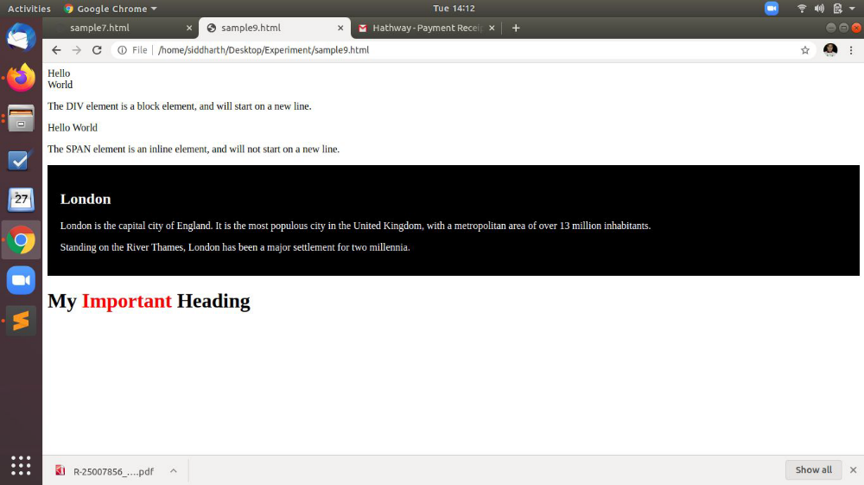

References:
- https://www.w3schools.com/html/html_intro.asp
- https://www.tutorialspoint.com/css/index.htm
- https://www.javatpoint.com/css-tutorial

Activity 12
Aim: Create Lists and Tables
Learning outcome: Able to create style of web pages using CSS.
Duration: 1 hour
List of Hardware/Software requirements:
- Laptop/Computer with Linux OS - Ubuntu 18.04 LTS
- Editor (Default Gedit or any other) and a Browser
Program:
<html>
<head>
<style>
/*setting the list style type of class a */
ul.a {
list-style-type: circle;
}
/*setting the list style type of class b */
ul.b {
list-style-type: square;
}
/*setting the list style type of class c */
ol.c {
list-style-type: upper-roman;
}
/*setting the list style type of class d */
ol.d {
list-style-type: lower-alpha;
}
/*setting the border collapse and width of table */
table {
border-collapse: collapse;
width: 100%;
}
/*setting alignment and padding of table heading and table data */
th, td {
text-align: left;
padding: 8px;
}
/*setting the background color property of table row */
tr:nth-child(even) {background-color: #f2f2f2;}
</style>
</head>
<body>
<p>Example of unordered lists:</p>
<ul class="a">
<li>Coffee</li>
<li>Tea</li>
<li>Coca Cola</li>
</ul>
<ul class="b">
<li>Coffee</li>
<li>Tea</li>
<li>Coca Cola</li>
</ul>
<p>Example of ordered lists:</p>
<ol class="c">
<li>Coffee</li>
<li>Tea</li>
<li>Coca Cola</li>
</ol>
<ol class="d">
<li>Coffee</li>
<li>Tea</li>
<li>Coca Cola</li>
</ol>
<h2>Striped Table</h2>
<p>For zebra-striped tables, use the nth-child() selector and add a background-color to all even (or odd) table rows:</p>
<table>
<tr>
<th>First Name</th>
<th>Last Name</th>
<th>Points</th>
</tr>
<tr>
<td>Peter</td>
<td>Griffin</td>
<td>$100</td>
</tr>
<tr>
<td>Lois</td>
<td>Griffin</td>
<td>$150</td>
</tr>
<tr>
<td>Joe</td>
<td>Swanson</td>
<td>$300</td>
</tr>
<tr>
<td>Cleveland</td>
<td>Brown</td>
<td>$250</td>
</tr>
</table>
</body>
</html>

Output/Results snippet
Designing of List and Tables using CSS.
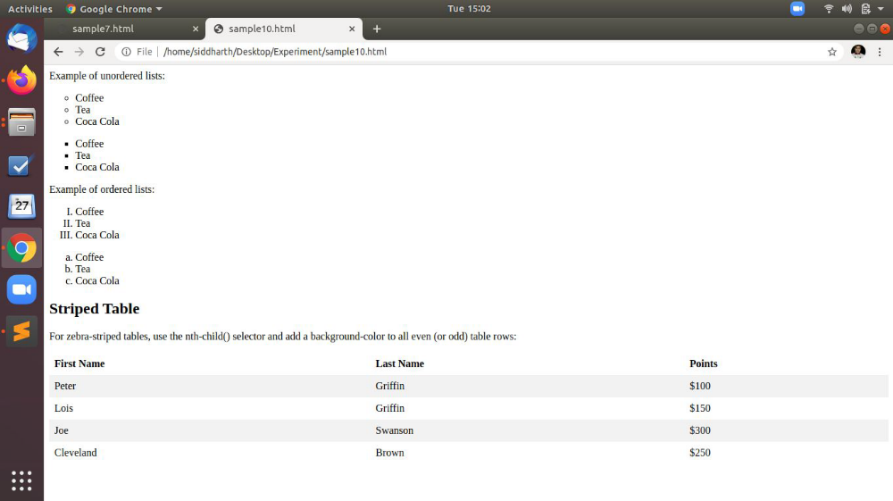

References:
- https://www.w3schools.com/html/html_intro.asp
- https://www.tutorialspoint.com/css/index.htm
- https://www.javatpoint.com/css-tutorial

Activity 13
Aim: Create Box Model by using borders, Padding and Margin
Learning outcome: Able to create style of web pages using CSS.
Duration: 1 hour
List of Hardware/Software requirements:
- Laptop/Computer with Linux OS - Ubuntu 18.04 LTS
- Editor (Default Gedit or any other) and a Browser
Program:
<!DOCTYPE html>
<html>
<head>
<style>
/*setting border padding and margin property */
div {
background-color: lightgrey;
width: 300px;
border: 25px solid green;
padding: 25px;
margin: 25px; }
</style>
</head>
<body>
<h2>Demonstrating the Box Model</h2>
<p>The CSS box model is essentially a box that wraps around every HTML element. It consists of: borders, padding, margins, and the actual content. </p>
<div>This text is the actual content of the box. We have added a 25px padding, 25px margin and a 25px green border. </div>
</body>
</html>

Output/Results snippet
Created a Box with border and color.
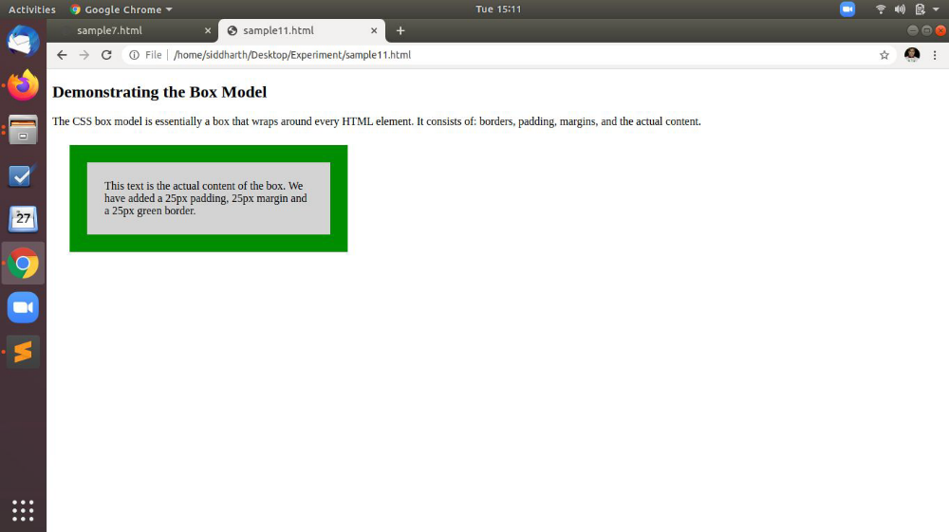

References:
- https://www.w3schools.com/html/html_intro.asp
- https://www.tutorialspoint.com/css/index.htm
- https://www.javatpoint.com/css-tutorial

